C:\Documents and Settings\julia.powell\My Documents\IHO TSMAD\S100-0 main\IHO S-100 Main Oct 1 2007.doc © ISO/IEC 2007 – All rights reservedISO-IEC_ 63Complementary elementIntroductory element — Main elementÉlément introductif — Élément central — Élément complémentaireIntroductory element — Main element — Complementary elementE2007-10-2 ISO/IECISO/IEC     2007 ISO/IEC ISO/IEC _(E).        2Heading 2Heading 1    02 STD Version 2.1c20   4            **INTERNATIONAL HYDROGRAPHIC ORGANIZATION**



**MARITIME LIMITS AND BOUNDARIES**

**PRODUCT SPECIFICATION**

**IHO ation S-121**

**Annex E**

**GML Data Format Description**

**Edition 1.0.0 – June 2020**

Published by the

International Hydrographic Organization

4b quai Antoine 1er

Principauté de Monaco

Tel: (377) 93.10.81.00

Fax: (377) 93.10.81.40

E-mail: [info@iho.int](mailto:info@iho.int)

Web: [www.iho.int](http://www.iho.int)

|  |
| --- |
| © Copyright International Hydrographic Organization 2019 |
| This work is copyright. Apart from any use permitted in accordance with the [Berne Convention for the Protection of Literary and Artistic Works](http://www.wipo.int/treaties/en/ip/berne/trtdocs_wo001.html) (1886), and except in the circumstances described below, no part may be translated, reproduced by any process, adapted, communicated or commercially exploited without prior written permission from the International Hydrographic Organization (IHO). Copyright in some of the material in this publication may be owned by another party and permission for the translation and/or reproduction of that material must be obtained from the owner. |
| This document or partial material from this document may be translated, reproduced or distributed for general information, on no more than a cost recovery basis. Copies may not be sold or distributed for profit or gain without prior written agreement of the IHO Secretariat and any other copyright holders. |
| In the event that this document or partial material from this document is reproduced, translated or distributed under the terms described above, the following statements are to be included: |
| *“Material from IHO publication [reference to extract: Title, Edition] is reproduced with the permission of the IHO Secretariat (Permission No ……./…) acting for the International Hydrographic Organization (IHO), which does not accept responsibility for the correctness of the material as reproduced: in case of doubt, the IHO’s authentic text shall prevail. The incorporation of material sourced from IHO shall not be construed as constituting an endorsement by IHO of this product.”* |
| *“This [document/publication] is a translation of IHO [document/publication] [name]. The IHO has not checked this translation and therefore takes no responsibility for its accuracy. In case of doubt the source version of [name] in [language] should be consulted.”*  The IHO Logo or other identifiers shall not be used in any derived product without prior written permission from the IHO Secretariat. |

Document Control

Changes to this Product Specification are coordinated by the IHO S-121 Project Team (S-121PT) which is a subsidiary of the S-100 Working Group (S-100WG). New editions will be made available via the IHO web site.

|  |  |  |  |
| --- | --- | --- | --- |
| **Edition Number** | **Date** | **Author** | **Purpose** |
| Draft 1.0.0 | June 2020 | J Pritchard | Initial Draft. |

Contents

1. Introduction 5

2. GML Application Schema Details 6

Feature Aggregation into Datasets 6

3. GML Encoding Notes 8

4. Geospatial Features 9

Overview. 9

Geospatial Feature relationships. 12

Element definitions – Geospatial features. 12

AbstractGeographicFeatureType 12

AbstractLimitType 13

AbstractLocationType 14

AbstractZoneType 14

AdditionalSpatialInformation 14

FeatureName 14

LocationReference 15

CategoryOfLocation 15

JurisdictionDomain 16

PointType 16

ReleasabilityType 17

5. LADM ISO19152 Information Types 18

Overview. 18

Basic Administrative Unit 18

Governance 19

Party 19

PartyMembership 20

AbstractRRR 20

Responsibility 20

Restriction 20

Right 21

CategoryOfResponsibility 21

CategoryOfRestriction 21

CategoryOfRight 22

PartyGroupType 22

6. Source Documentation 23

Overview. 23

7. Feature Associations 25

Geospatial and Information Type feature hierarchies. 25

Geospatial to BAU features 26

Source relationships. 27

Party / Party Member relationships 27

Rights, Restrictions and Responsibilities 27

8. References 28

# Introduction

This document contains details of the IHO S-121 GML Encoding format. In order to reduce complexity and provide a concise guide to the structure of the GML Encoding a subset of all elements within the encoding are provided here alongside any necessary detail and background of the schema itself.

There is a large degree of duplication in the types within the S-121 GML Application Schema so duplicated types are noted, but the repeated detail left out of this document. The schema document itself contains normative definitions for all types and references to the S-100 base schemas.

The GML Application schema for IHO S-121 was developed initially within the Open Geospatial Consortium’s (OGC) Maritime Limits and Boundaries Pilot Project. This pilot project was a collaborative effort between member states and industry and aimed to show the potential of IHO S-121 and examples of data production using the defined model and both COTS and open source tools. The core of the OGC Pilot project was the construction of a draft GML Schema which :

1. Conformed with S-100 Part 10b (and thus was an IHO conformance GML Schema)
2. Was interoperable with OGC web services and standards.

The GML Schema generated within the OGC Pilot is the foundation for the Schema presented here. This document details the structure and content of the GML Schema. The schema is conformance with S-100 Part 10b, except where noted any interpretations and/or deviations from existing norms.

This document does not provide normative definitions of the attributes or non-abstract feature and information types within the schema. These definitions may be found within the IHO S-121 product specification documentation and within the IHO geospatial registry. Given the nature of the UNCLOS convention definitions are by reference and not textually reproduced. Similarly, definitions of information types forming the LADM and Source elements of the GML Application Schema may be found within either ISO19152 or ISO19115 as appropriate.

# GML Application Schema Details

There are three main packages contained within the S-121 GML Schema. These are documented individually within this document, mainly by inclusion of UML diagrams which show the implementation within the GML Application Schema. The three main packages are:

1. The Geospatial features. These geospatial features (i.e. those features with a defined geometry) are derived directly from the feature set identified by the S-121 project team as a subset of those defined within UNCLOS. This set of features is further subdivided into Location (Point primitive), Limit (Curve primitive) and Zone (Surface primitive) groups as per the S-121 information model.
2. LADM features. These information types (in the S-100 sense) and their relationships model the implementation of ISO19152. They are composed of Basic Administrative Units, Governance, Party/Party Member structures together with Rights/Restrictions and Responsibilities. A full description of how the LADM is implemented is contained within the main S-121 product specification Application Schema description.
3. Source features. This is a single information type containing simple and complex attributes which model a subset of the ISO19115 fields required for documenting the source of individual features within a particular dataset. These are independent of any dataset metadata that may also be included at the dataset level.

The following diagram summarises the individual elements of the schema and shows their relationships. The detail of individual relationships, multiplicities and naming is contained in the Feature Associations section of this document.

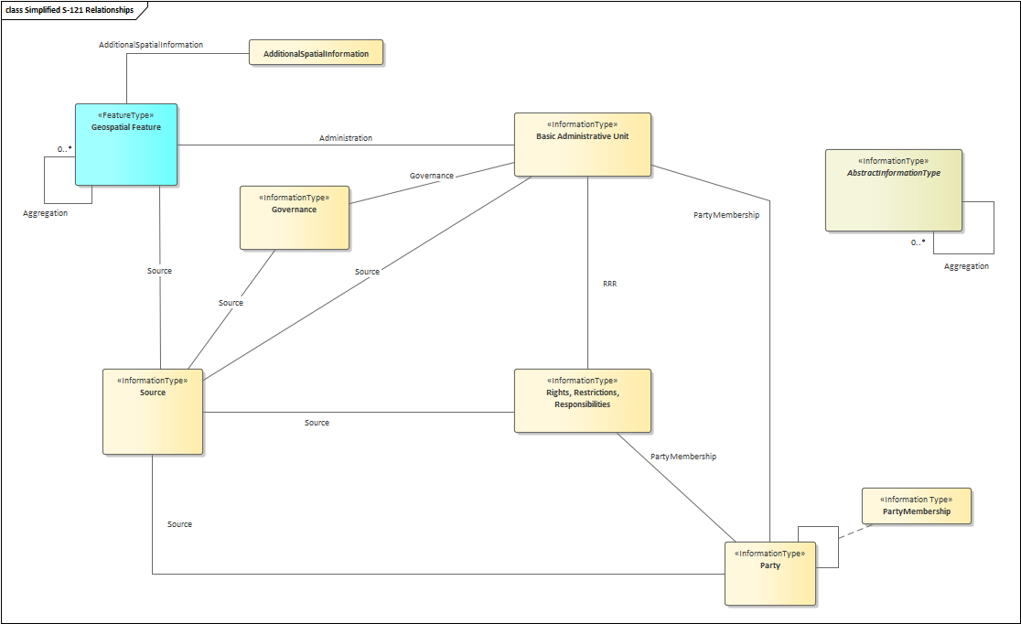

Figure 1: Simplified View of packages and their relationships within the schema (v1.0.0)

## Feature Aggregation into Datasets

Within the GML Schema the S-100 GML profile structure is followed. In order to aggregate S-121 features and information types into datasets a Feature Collection element is defined according to the broad guidelines in Part 10b-0.9. This aggregation elements, “Dataset”, is illustrated in the following diagram:

Figure 2: Dataset Collection type

The dataset collection type is derived from gml:AbstractFeatureType in order to ensure an S-121 dataset is a valid GML document. An S-121 dataset consists of three sections:

1. A metadata element containing s100:DatasetIdentificationInformation and s100:DatasetStructureInformation elements. These are parts of the existing S-100 profile and although derived largely from ENC roots they contain useful metadata elements.
2. Any S-100 geometry elements required. The GML Schema supports the use of both inline geometry (i.e. defined within the feature itself) and geometry by reference. In line with existing S-100 practices, as far as possible elements are defined prior to use and therefore the S-100 geometry elements are defined prior to any feature or information types. These are standard S-100 geometry types from a group defined in the S-100 GML profile. GML identifiers provide a method for unique identifiers to form relationships between geospatial features and referenced geometry.
3. A “members” element containing all feature and information types within the dataset. These are drawn from a group defined in the schema (“Features”) and are not prefixed with “member”/”imember” elements. There is no implicit ordering in the schema between feature types and information types.

# GML Encoding Notes

This section details the implementation of the S-100 GML Profile used within the S-121 GML Application Schema and notes areas where this may differ from other GML formats in the S-100 ecosystem.

1. As per S-100 Part 10b 8.5.4 the GML profile supports either inline or by-reference encoding of geometry. In accordance with the underlying GML standard if both are given then the inline geometry takes precedence (and, as dual representation is not validated under XML Schema validation the capture of dual representations of geometry should be trapped by validation in addition to validation against the GML Schema.
2. In accordance with the GML profile topology is not defined within the GML Schema. Although some toplogical elements may be implemented (such as shared geometry between baseline and boundary points and coincident geometry between components of baselines and their component features) this can not be enforced at a topological level and therefore additional validation may be required to ensure a dataset it topologically consistent.
3. The base S-100 Profile types for feature and information types have been used, thus implementing basic features, generic feature and information type associations and feature object identifiers (foid). Any other identifiers used by data producers, such as the optional MRN mechanisms is at the discretion of the data producer, and in addition to the embedded foid mechanism.
4. In accordance with 10b-14 geometry is used as the element name to carry geometry. By-reference geometry elements are encoded as per S-100, e.g. S-100:Point but embedded geometry is labelled using the gml: namespace. This is to ensure interoperability with COTS and open Source libraries GDAL/ogr. This may be revised in a later edition of the GML Annex.
5. As per 10b-9.9 a dataset definition is included in the GML Application Schema. This is detailed in the Feature Aggregation section of this document. Under 10b-9.6 the dataset general information elements have been included including the fields under DatasetIdentificationType providing a minimum level of dataset level metadata.
6. IHO Schemas and Application Profiles have been included from the GI Registry website.
7. Where relationships are defined the role name is used as the property element as per 10b-9.5.2 rather than the generic mechanism defined in 10b-9.5.1. In addition, care has been taken not to conflict role names with the names of feature or information types as these conflicts can cause issues with COTS applications.
8. Date types have been implemented as standardised XML dates, not S-100 date types for better interoperability and flexibility for data producers. Additionally XML String data types are used for textual content. This is noted in 10b-8.4.1 and 10b-8.4.3
9. For enumerated types the S-100 feature catalogue code is used to represent each enumerated value as per 10b-14. There is no attributeEncoding field in the dataset header metadata currently (as inferred by Part 10b). This may lead to an extra field being added to the dataset metadata to denote adoption of this convention.
10. The GML profile only uses GML v3.2.1, not GML 3.3 for better interoperability with client COTS and open source tools.

# Geospatial Features

An illustration of all the features within the Geospatial category of the GML Schema are shown in the UML diagram below.



1. Geospatial Features

## Overview.

All geospatial features within the GML Application Schema derive from a single *AbstractGeographicFeature* type illustrated in the following diagram.

Figure 3: Base Abstract Geographic feature

The abstractGeographicType contains all the generic elements required for geospatial features. Further subtypes are derived from abstractGeographicType to implement individual features in the three main categories:

1. Point features. Those features with Point geographic primitives. In the UNCLOS context these are baseline points, limit points, boundary points and contributing points. An additional generic “Location” is defined.
2. Curve features. These are features with the S-100 geometry primitive “Curve”. These features represent UNCLOS limits, baselines and boundaries.
3. Zone features. Features with a “Surface” geometry primitive. These represent UNCLOS zones such as Territorial Sea, EEZ etc as well as Internal Waters and High Seas. There is also a generic “Zone” feature defined within the Schema.

The attributes and types are illustrated in the following diagram:

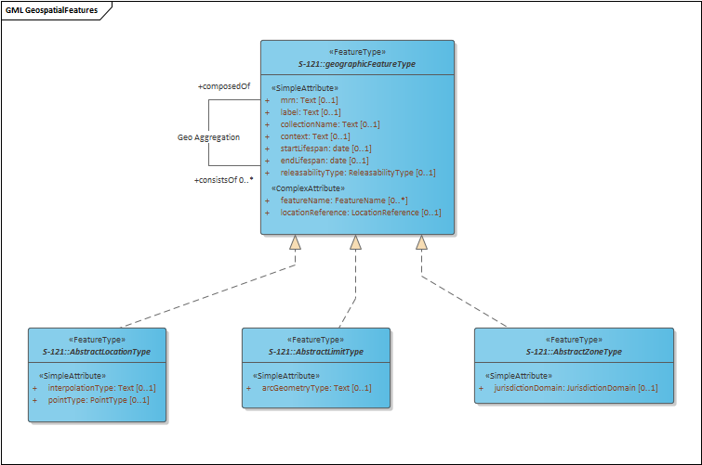

Figure 4: Geospatial feature hierarchy in the schema

Point Features which derive from this feature types are:

1. Baseline Point
2. Limit Point
3. Boundary Point
4. Contributing Point

All Line features (baselines, outer limits) derived from this feature type are:

1. Baseline
2. NormalBaseline
3. StraightBaseline
4. ArchipelagicBaseline
5. LowTideElevationBaseline
6. MouthOfRiversBaseline
7. BayBaseline
8. PortBaseline
9. ReefBaseline
10. Boundary
11. InternationalBoundary
12. Limit
13. OuterLimitOfTheTerritorialSea
14. OuterLimitOfTheContiguousZone
15. OuterLimitOfTheExclusiveEconomicZone
16. OuterLimitOfTheContinentalShelf
17. OuterLimitOfTheRoadstead
18. ConstructionLine

All Area features (Zones) derived from this feature type are:

1. Zone
2. TerritorialSea
3. ContiguousZone
4. ExclusiveEconomicZone
5. ContinentalShelf
6. Roadstead
7. InternalWaters
8. TheArea
9. HighSeas
10. ArchipelagicWaters
11. Strait

## Geospatial Feature relationships.

The main relationships to note within the geospatial features are as follows:

1. Aggregation of geospatial features. All geospatial features can be aggregated together using consistsOf/composedOf relationships. This allows arbitrary hierarchies to be built within datasets reflecting individual practice of producing states.
2. Association of geospatial features to AdditionalSpatialInformation. Each geospatial feature can have a single inline locationReference element which allows the textual description of a location (or series of locations) and associated reference system. In order to provide for multiple location references, and to allow such references to be shared between multiple geospatial features a relationship to the AddditionalSpatialInformation information type is defined.

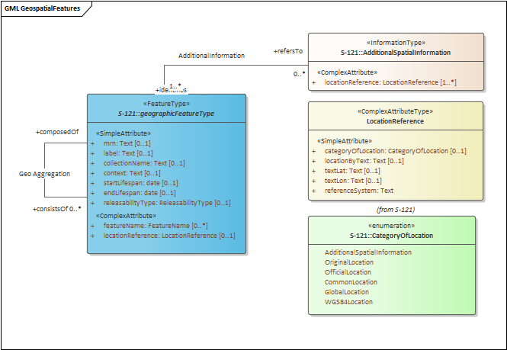

Figure 5: Relationship of geospatial features to information type AdditionalSpatialInformation.

## Element definitions – Geospatial features.

### AbstractGeographicFeatureType

| ATTRIBUTES |
| --- |
| mrn : Text  Multiplicity: ( [0..1], )  MRN has been added to the GML Schema and Feature catalogue. This requires harmonisation with other efforts within the IHO geospatial registry in line with its inclusion within the S-100 framework. MRN in the context of S-121 is "optional" - the option of using the S-100 Profile's FeatureObjectIdentifier element ("foid") is an acceptable alternative as a persistent unique identifier for individual features. |
| label : Text  Multiplicity: ( [0..1], ) |
| collectionName : Text  Multiplicity: ( [0..1], )  A textual label representing a neutral "Collection" label for the feature. This allows multiple groupings (either by state, function or other criteria) to exist within a single dataset. |
| featureName : FeatureName  Multiplicity: ( [0..*], ) |
| context : Text  Multiplicity: ( [0..1], ) |
| startLifespan : date  Multiplicity: ( [0..1], ) |
| endLifespan : date  Multiplicity: ( [0..1], ) |
| locationReference : LocationReference  Multiplicity: ( [0..1], )  An inline locationReference attribute - this allows inclusion of a single textual representation of a location if required. If multiple textual representations are required then they should be specified using an association with the AdditionalSpatialInformation information type. |

## AbstractLimitType

| ATTRIBUTES |
| --- |
| interpolationType : Text  Multiplicity: ( [0..1], ) |

## AbstractLocationType

| ATTRIBUTES |
| --- |
| interpolationType : Text  Multiplicity: ( [0..1], ) |
| pointType : PointType  Multiplicity: ( [0..1], ) |

## AbstractZoneType

| ATTRIBUTES |
| --- |
| jurisdictionDomain : JurisdictionDomain  Multiplicity: ( [0..1], ) |

## AdditionalSpatialInformation

An information type holding a number of locationReference entries. This can store multiple textual representations of a position and reference system and can be shared between multiple geospatial features as well.

| ATTRIBUTES |
| --- |
| locationReference : LocationReference  Multiplicity: ( [1..*], ) |

## FeatureName

Class «ComplexAttributeType» in package 'S-121'

A copy of the IHO registry entry for Naming of features. This complex attribute allows for a number of names to be stored alongside a language identifier. The attribute "displayName" is included for compatibility with other featureName uses and could possibly be removed in the future.

| ATTRIBUTES |
| --- |
| displayName : boolean Private |
| Language : Text Private |
| Name : Text Private |

## LocationReference

DataType «ComplexAttributeType» in package 'S-121'

| ATTRIBUTES |
| --- |
| categoryOfLocation : CategoryOfLocation  Multiplicity: ( [0..1], ) |
| locationByText : Text  Multiplicity: ( [0..1], )  If a location is not described in latitude/longitude form then a textual description of a position (or number of positions) can be described in locationByText |
| textLat : Text  Multiplicity: ( [0..1], )  Textual representation of a latitude position. |
| textLon : Text  Multiplicity: ( [0..1], )  Textual representation of a longitude. |
| referenceSystem : Text  A textual description or reference to the reference system for a textually defined position. this could be a formal datum or description of a datum (historical) |

## CategoryOfLocation

Enumeration in package 'S-121'

| ATTRIBUTES |
| --- |
| AdditionalSpatialInformation : |
| OriginalLocation : |
| OfficialLocation : |
| CommonLocation : |
| GlobalLocation : |
| WGS84Location : |

## JurisdictionDomain

Enumeration in package 'S-121'

| ATTRIBUTES |
| --- |
| Airspace : |
| Land Surface : |
| Water Surface : |
| Water Column : |
| * Seabed Surface : |
| Subsoil : |

## PointType

Enumeration in package 'S-121'

| ATTRIBUTES |
| --- |
| defined : |
| computed : |

## ReleasabilityType

Enumeration in package 'S-121'

| ATTRIBUTES |
| --- |
| Official : |
| Internal : |
| Controlled : |

# LADM ISO19152 Information Types



1. LADM Features

## Overview.

## Basic Administrative Unit

Class «InformationType» in package 'S-121'

| ATTRIBUTES |
| --- |
| basicAdministrativeUnitName : Text |
| basicAdministrativeUnitType : Text  Multiplicity: ( [0..1], ) |
| basicAdministrativeUnitContext : Text  Multiplicity: ( [0..1], ) |

## Governance

AssociationClass «Information Type» in package 'S-121'

| ATTRIBUTES |
| --- |
| label : Text |
| referenceNumber : Text |
| governanceTitle : Text |
| governanceDescription : Text |
| releasabilityType : ReleasabilityType Private |
| dateConsidered : date |
| dateApproved : date |
| dateIntroduced : date |
| featureName : FeatureName |

## Party

Class «InformationType» in package 'S-121'

| ATTRIBUTES |
| --- |
| partyName : int Private |
| partyRole : int Private  Multiplicity: ( [0..1], ) |
| categoryOfParty : int Private  Multiplicity: ( [0..1], ) |
| partyGroupType : PartyGroupType Private |
| partyGroup : boolean Private |

## PartyMembership

AssociationClass «InformationType» in package 'S-121'

| ATTRIBUTES |
| --- |
| partyMembership : Double |

## AbstractRRR

Class «InformationType» in package 'S-121'

| ATTRIBUTES |
| --- |
| rrrDescription : Text  Multiplicity: ( [0..1], ) |
| rrrTimespec : Date  Multiplicity: ( [0..1], ) |
| rrrShare : Double  Multiplicity: ( [0..1], ) |

## Responsibility

Class «InformationType» in package 'S-121'

| ATTRIBUTES |
| --- |
| categoryOfResponsibility : CategoryOfResponsibility  Multiplicity: ( [0..1], ) |

## Restriction

Class «InformationType» in package 'S-121'

| ATTRIBUTES |
| --- |
| categoryOfRestriction : CategoryOfRestriction  Multiplicity: ( [0..1], ) |

## Right

Class «InformationType» in package 'S-121'

| ATTRIBUTES |
| --- |
| categoryOfRight : CategoryOfRight  Multiplicity: ( [0..1], ) |

## CategoryOfResponsibility

Enumeration in package 'S-121'

| ATTRIBUTES |
| --- |
| Maintenance Responsibility : |

## CategoryOfRestriction

Enumeration in package 'S-121'

| ATTRIBUTES |
| --- |
| Access Restriction : |
| Jurisdiction Restriction : |
| Passage Restriction : |
| Resource Restriction : |
| Time Based Restriction : |
| Use Restriction : |

## CategoryOfRight

Enumeration in package 'S-121'

| ATTRIBUTES |
| --- |
| Sovereignty : |
| Sovereign Right : |
| Access Right : |
| Easement Right : |
| Harvest Right : |
| Contiguous Right : |

## PartyGroupType

Enumeration in package 'S-121'

| ATTRIBUTES |
| --- |
| Agreement : |
| Association : |

# Source Documentation



Figure: Implementation of Source information type

## Description.

The Source elements of the GML schema are taken from the source structures as defined in the main S-121 Model in the product specification. This has been reflected in the Feature Catalogue and in the GML Schema. The source information type is a flexible mechanism for attributing source information to individual geospatial features or LADM features (including groups of features formed by aggregation) rather than purely at the dataset level. This facilitates mixed datasets from a broad range of suppliers.

Relationships to Source information types is included in the base abstract types for geospatial features and information types. It can therefore be included (and shared between) any features or information types defined by data producers.

Figure 6: GML Schema structure of the Source Type

# Feature Associations

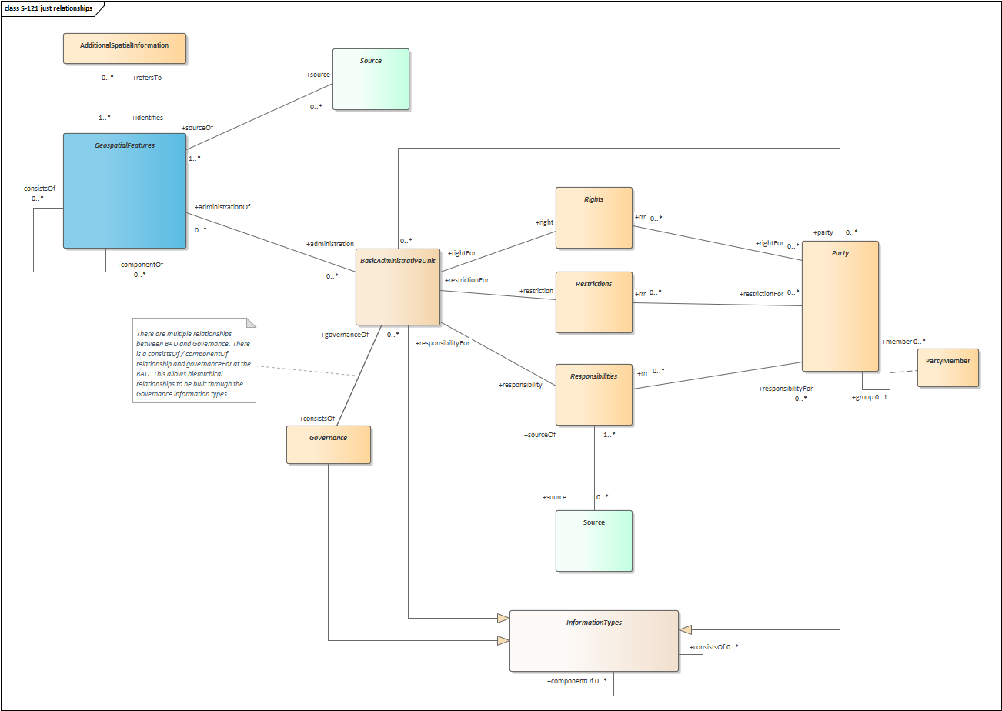

Relationships between features are realised through standard GML Reference Types in each of the respective features. They are documented here for clarity – the GML Schema contains all the necessary elements reflected in the diagram above.

## Geospatial and Information Type feature hierarchies.

All geospatial features and information types have consistsOf/componentOf 0-* relationships defined. These allow for arbitrary groupings to be defined between the types allowing hierarchies to be built up as required by individual data producers. For example a zone may be built up of baselines, boundaries and outer limits with the baseline also being built up from individual baseline sections. These relationships may not be in a strict hierarchy for legislative purposes (i.e. for textual extraction) hence the existence of arbitrary association relationships.

Figure 7: geographic feature type showing relationships

## Geospatial to BAU features

LADM is implemented through a relationship between the BasicAdministrativeUnit and any of the geospatial features derived from the abstractGeographicFeature type. This relationship is also a many-many one in order to allow arbitrary hierarchies and networks to be built depending on the preferences and characteristics of the individual data producer.

The references allowable within the scope of the GML Application Schema allow for relationships to express a hierarchy of BAU and intermediate governance information types and to provide governance for component parts of those hierarchies. An example is shown in the following diagram:

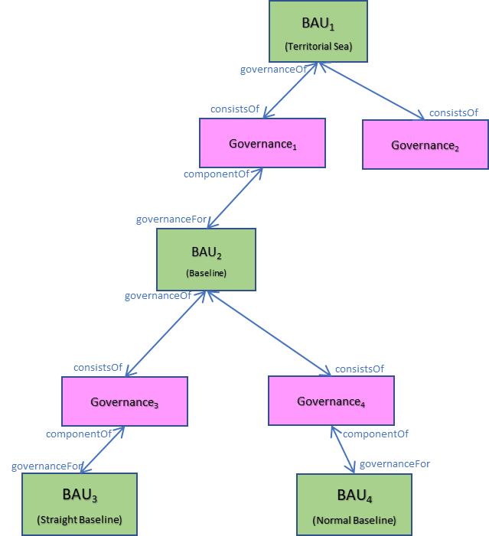

Figure 8: A mixed hierarchy of BAU and Governance information types

## Source relationships.

S-121 is unusual in that it allows for source information (derived from ISO19115 features and structures) to be defined against individual features and information types. The information type for Source is therefore also flexible in that it allows for multiple source features as well as a single source feature to be associated with many geospatial features or information types. An isolated source feature is not permitted (i.e. a source feature which is not the source “of” any geospatial feature or information type – in this case the source is held at the dataset metadata level).

## Party / Party Member relationships

Party/Party member relationships define the parties to an LADM Rights, Restrictions and Responsibilities structure as per ISO19152. Parties can be defined either standalone or via an optional intermediate class PartyMember which defines a “membership” proportion, should the data producer wish to encapsulate such a structure in the data. In order to allow for relationships between parties an optional aggregation using consistsOf/componentOf relationships are defined (again, through inheritance from the abstract information type).

## Rights, Restrictions and Responsibilities

RRR relationships are divided into two categories. Direct relationships with the BAU have roles named after the individual RRR (e.g. responsibility/responsibilityFor) and relationships with parties are labelled “rrr” and “repsonsibilityFor”,”rightFor”,”restrictionFor” to differentiate them.

# References

[1] IHO S-100 Edition 4.0.0 December 2018 Part 10b – GML Data Format

[2] ISO 19152 Land Administration Domain Model ISO19152

[3] ISO19115:2003 Geographic Information - Metadata

[4] ISO19136:2007 Geographic Markup Language (GML) v3.2.1